
Portfolio of evidence
Part 1


Name: Princesse Laurie Erika
Surname: Megha
Student number: ST10497718
Group: 1
Module: Introduction to Web Development
Module Code: WEDE5020
Due date: 20th April 2026
Lecturer: Kamanga Albert
Table of Contents
1. Organisation Overview 2
2. Website goals and objectives 2
3. Current Website Analysis 2
5. Design and User Experience 3
6. Technical requirements 5
7. Timeline and Milestones 6
8. Budget 6
References 7

Organisation Overview
Name: Global Sales Consultancy (GSC)
Global Sales Consultancy is a business that provides sales strategy, consulting, and support services to companies looking to improve their performance. The organisation works with businesses that want to increase revenue, improve customer relationships, and optimise their sales processes.
- Mission and Vision
The goal for this website is to centralise all support-related tools and information and simplify issue tracking and accelerate problem resolution.
- Target audience
This company is oriented to GSC IT consultants and technical support staff.

Website goals and objectives
Currently, GSC does not have a strong online presence, which makes it difficult for potential clients to understand its services.
- Goals:
Centralise operational information
Support daily tasks
Provide troubleshooting and escalation procedures
Offer access to forms and resources
- KPIs:
Website traffic
Number of enquiries
Improved efficiency

Current Website Analysis
GSC does not currently have a dedicated public website.
- Strengths:
Clear business model
Defined services
- Weaknesses:
No online platform to showcase services
Limited visibility to new clients
Lack of centralised information
- Areas for Improvement:
A website would allow GSC to improve accessibility
- Proposed Website features and functionality
- Homepage: Overview of GSC and its services
- Support: Solutions for common issues faced by agents.
- Escalation: Escalation steps
- Service requests: IT forms
- Contact Page/About Us: Enquiry form and contact details

Design and User Experience
Colour Scheme: Blue, white, gold
Typography: Montserrat for headings and Roboto for body
User experience: easy to navigate, mobile-friendly, and focused on presenting information clearly.
Wireframes:
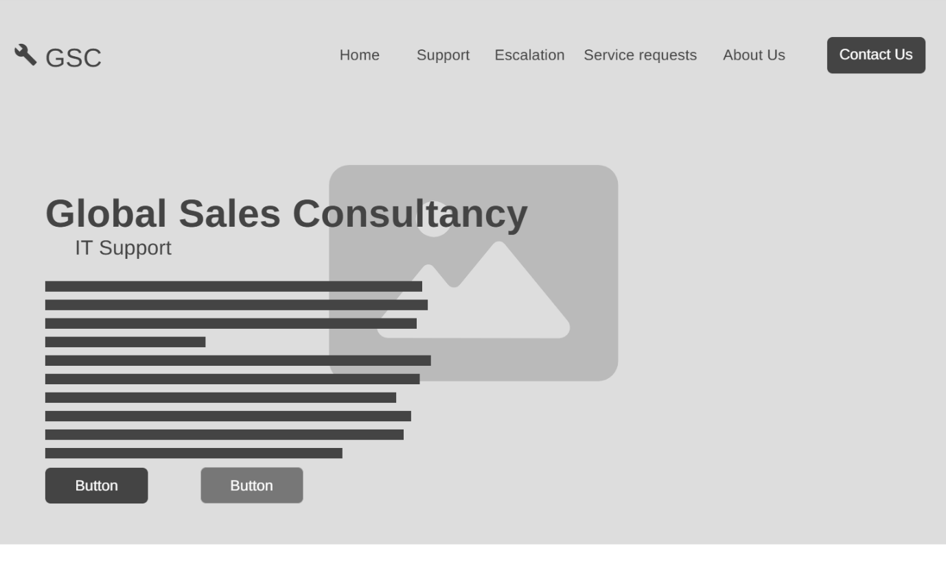
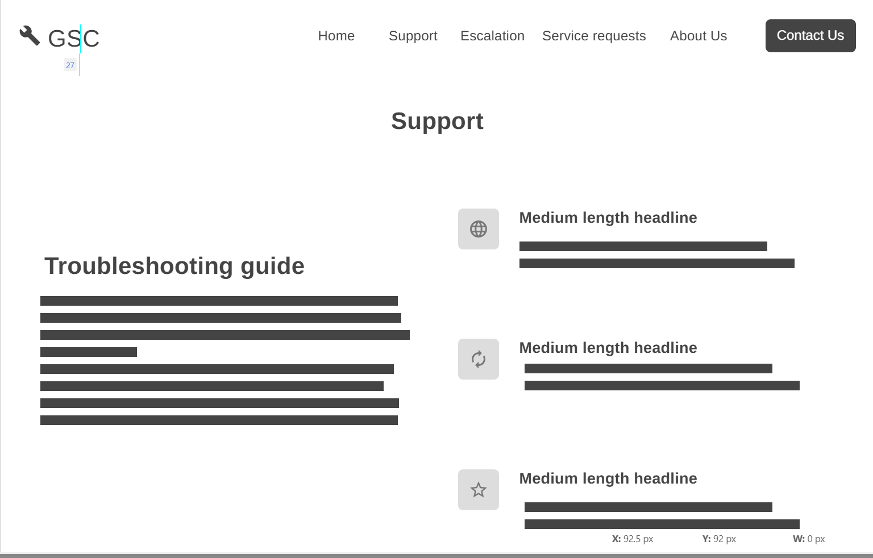
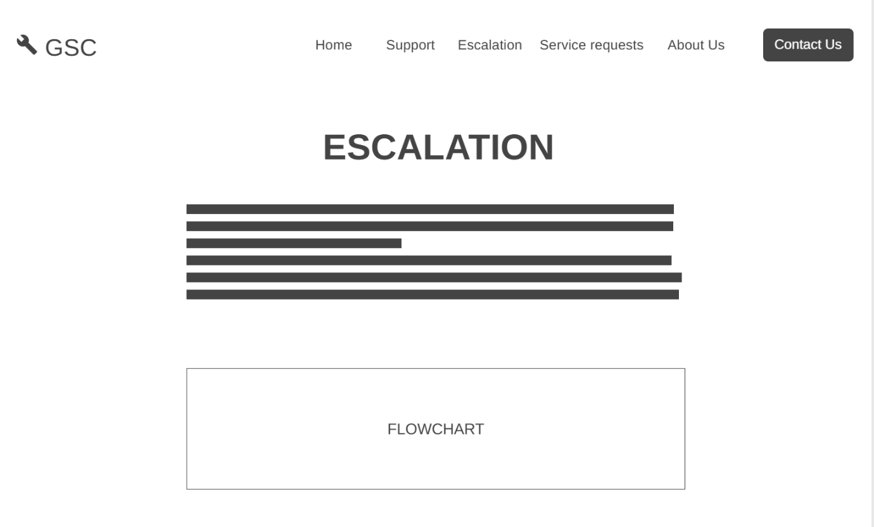
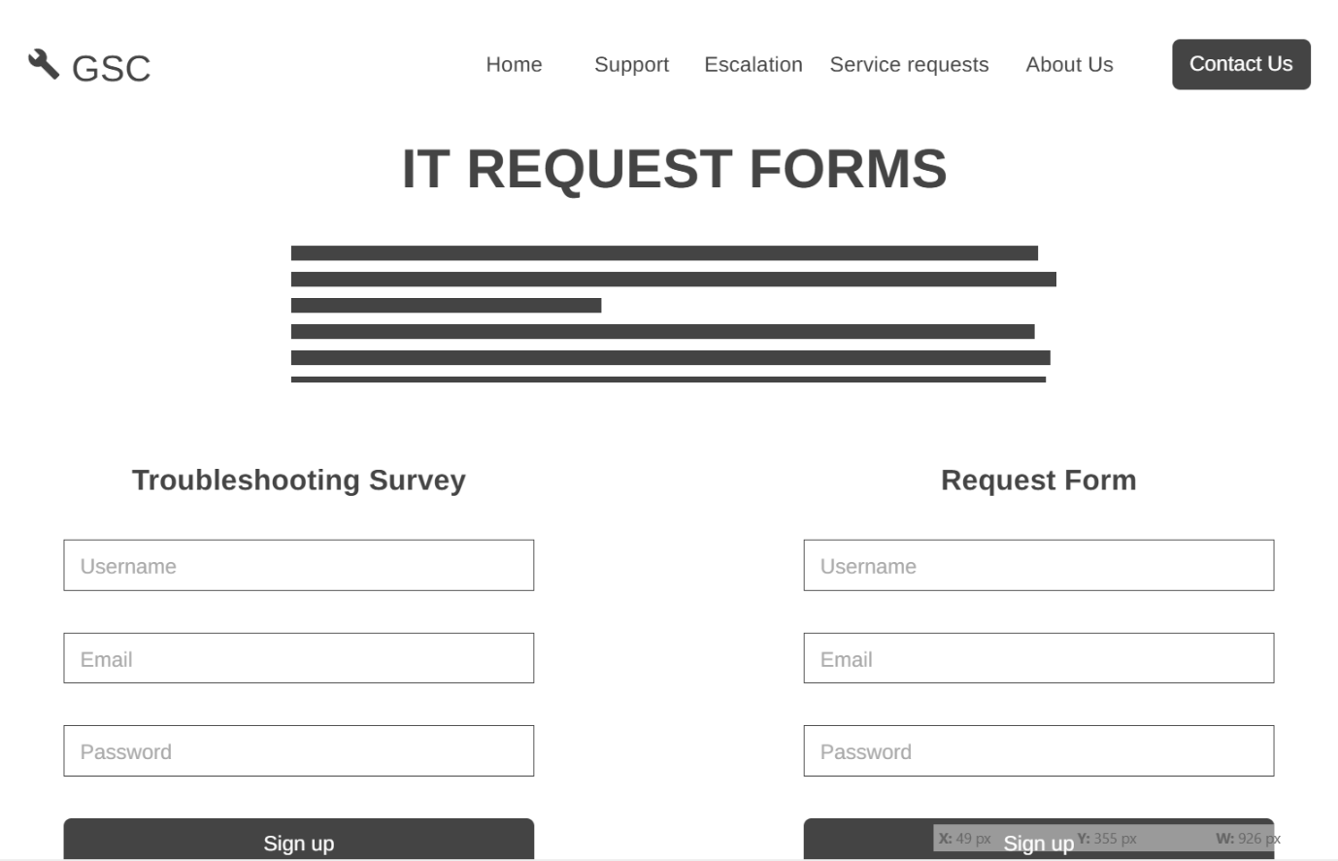
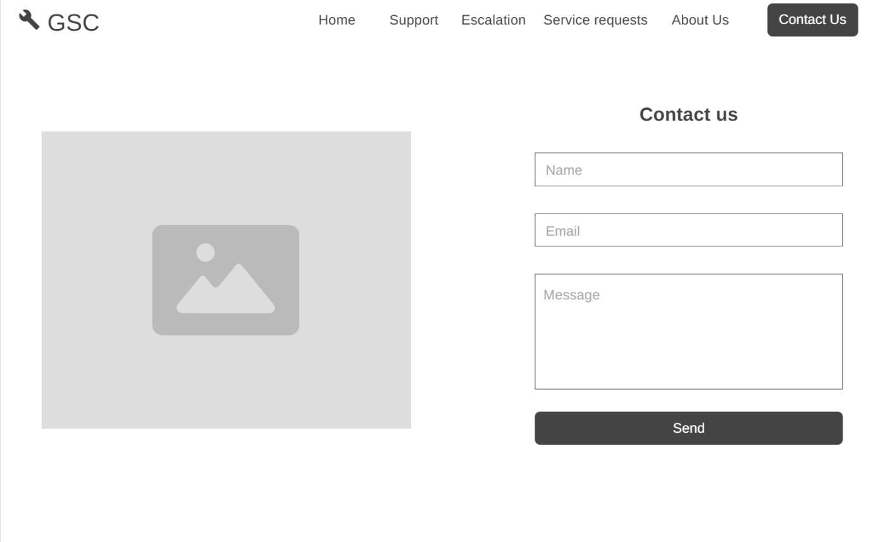

Technical requirements
- HTML
- CSS
- JavaScript
- Domain

Timeline and Milestones
Week 1- 2: Research, social media sourcing
Week 3-4: Building the wireframes and the basic HTML structure
Week 5-6: CSS styling and adjustments
Week 7-8: Responsive design
Week 9: JavaScript Implementation
Week 10: Final testing and adjustments

Budget
Development: R2500 - R5000(once-off)
Domain: R90 – R250 per year for a standard .co.za
Hosting: R299 - R499 per month
Maintenance: R299 - R499 per month
(S., 2026)

References
S., A., 2026. How Much Does It Cost to Build a Website in South Africa?. [Online]
Available at: https://hostafrica.co.za/blog/websites/website-basics/how-much-does-a-website-cost-in-south-africa/#breakdown-of-website-costs-in-south-africa
[Accessed 10 April 2026].

